Jenkins assignment 8 using pipeline
Create 3 repo on github and add index file in each repository then create 1 pipeline and then using all 3 instance id run that file
Step 1 – lauch jenkins master complete set up like java ,tomcat,Jenkins and open Jenkins dash board
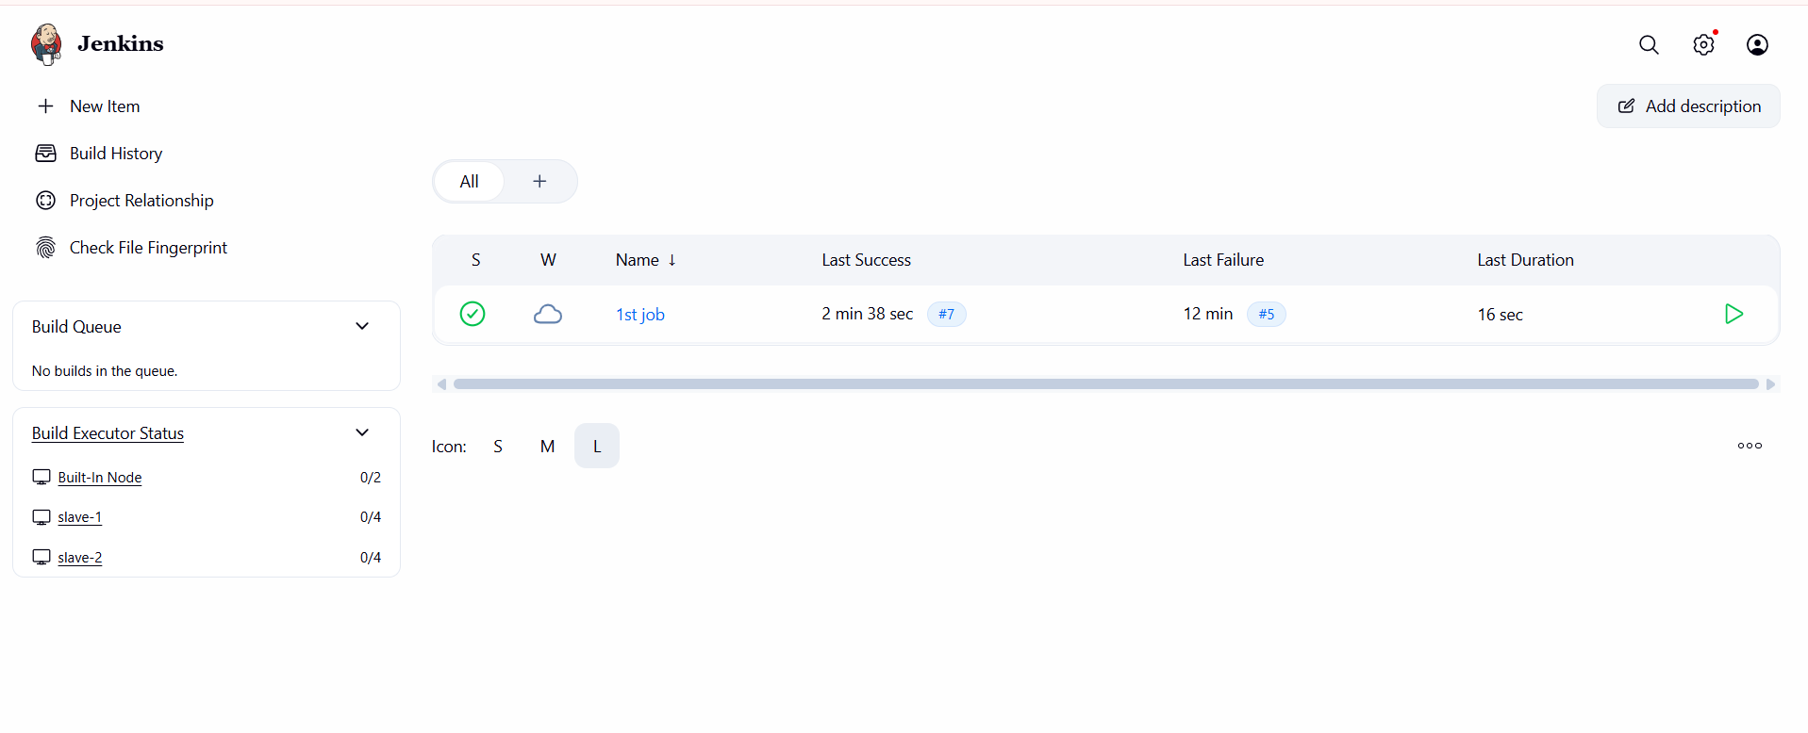
Step 2 – create 2 nodes so install 2 instances and add tomcat then give permission then add remote root directory and give permission
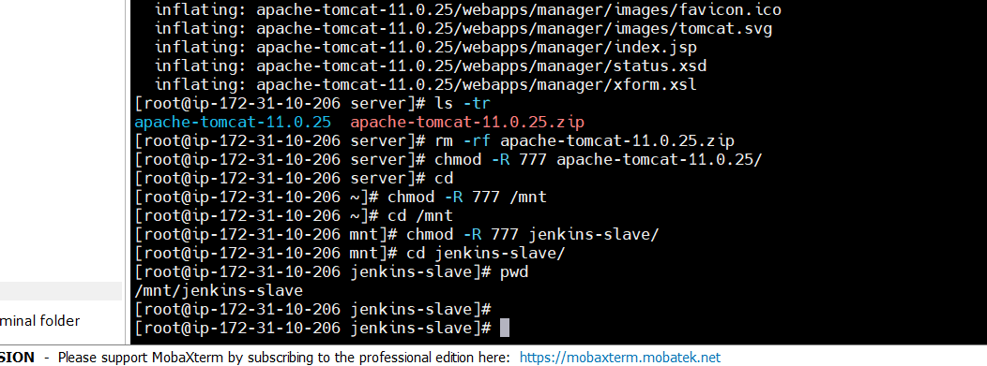
Step 3 – create node
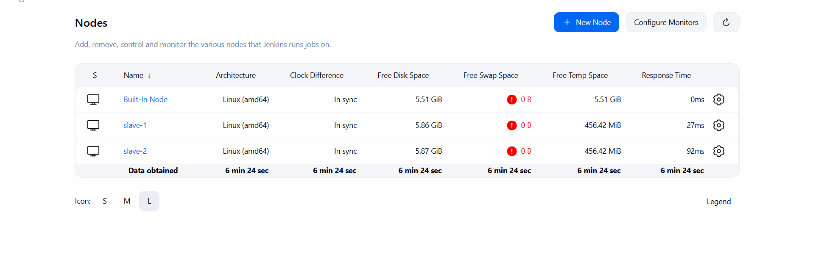
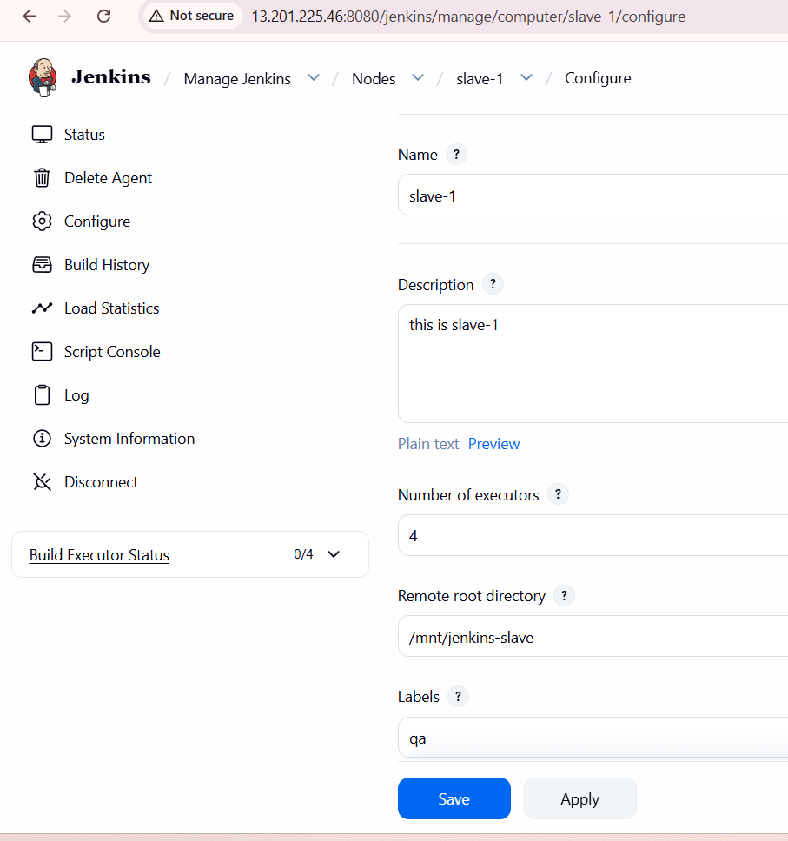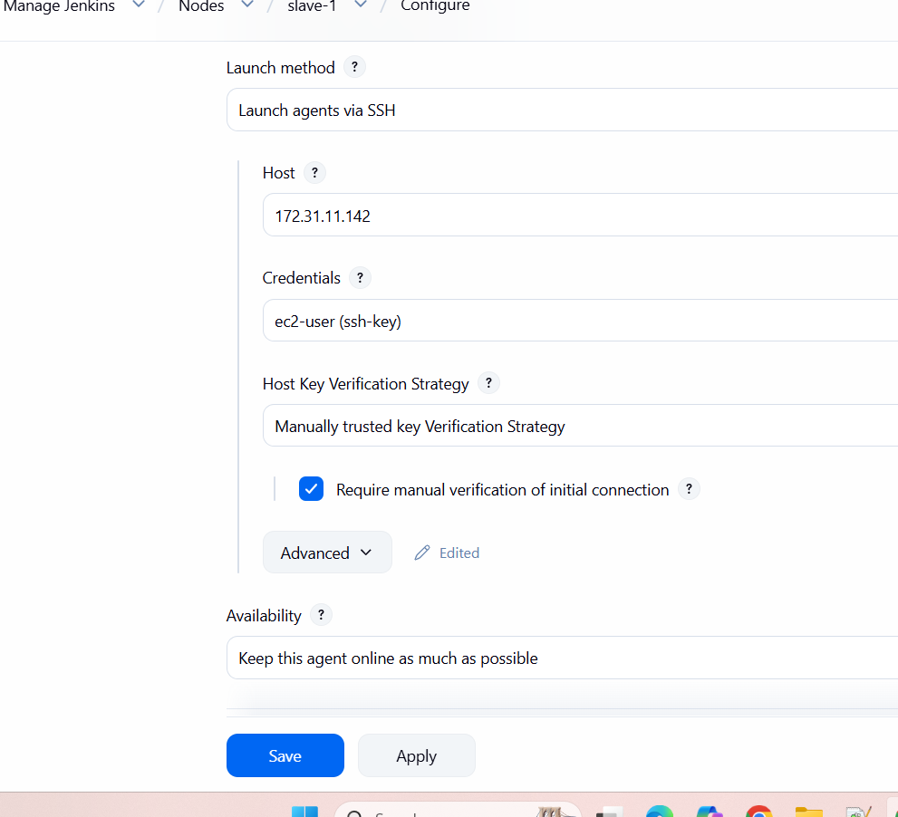
Step 4 – create pipeline code and check
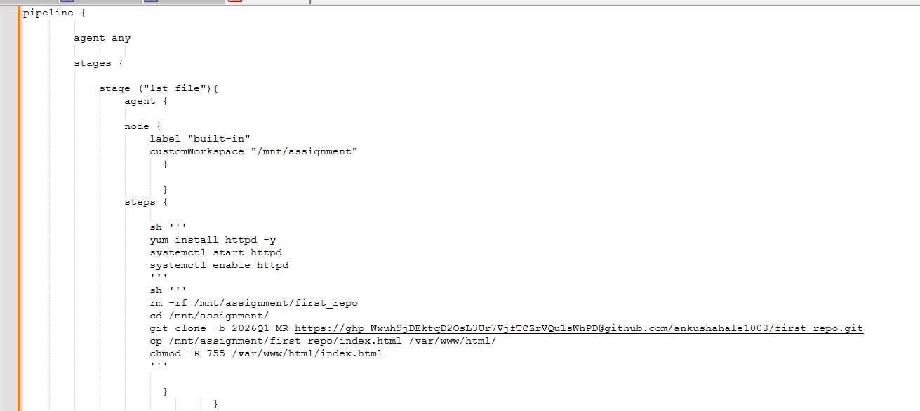
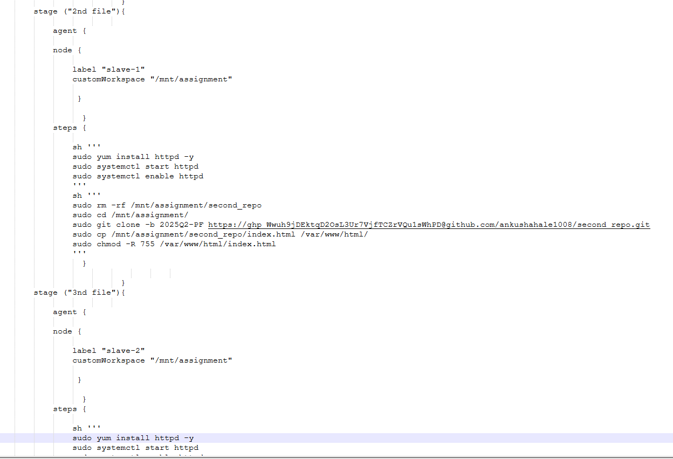
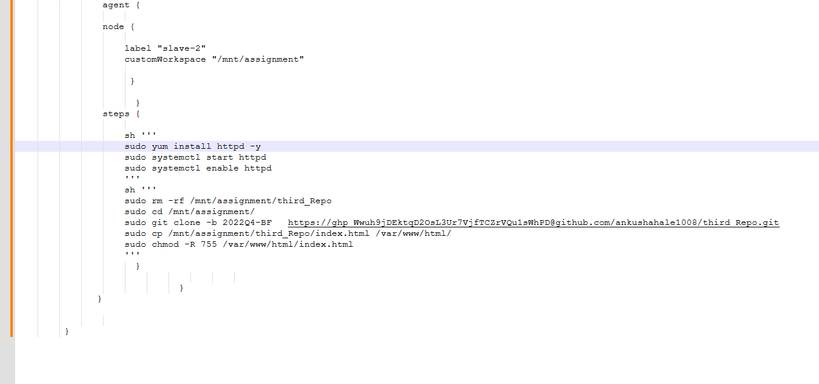
Step 5 – click on build now then check stages
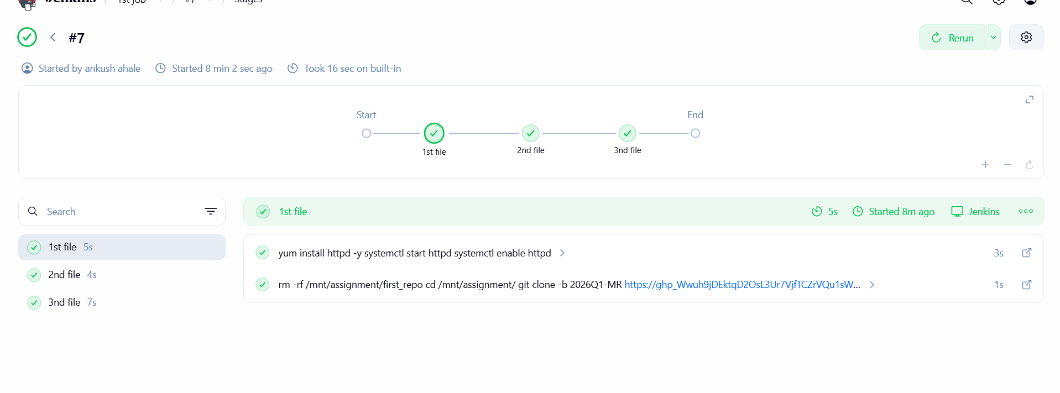
Step 6 – check using each ip
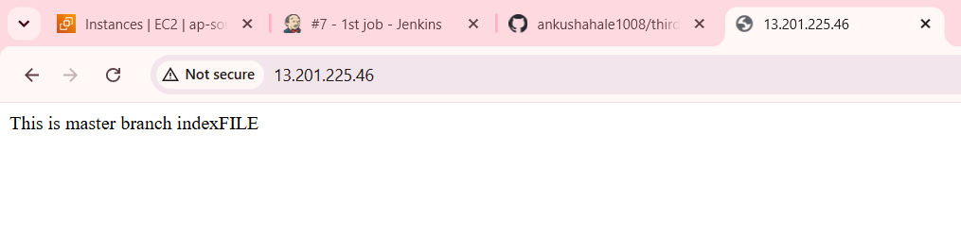
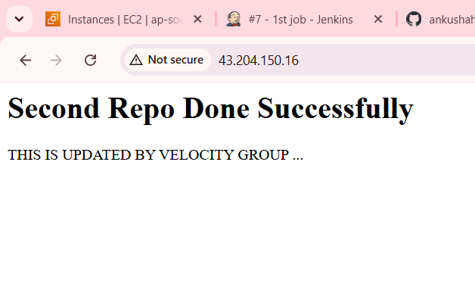
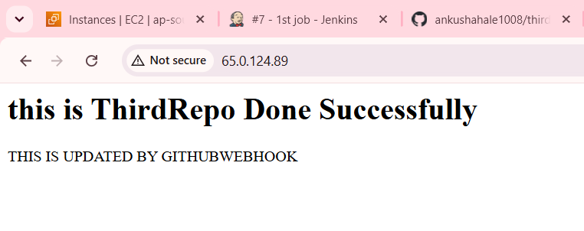
Done Successfully.

